**Deploy In Kubernetes Cluster**

1. Create configuration files for Kubernetes

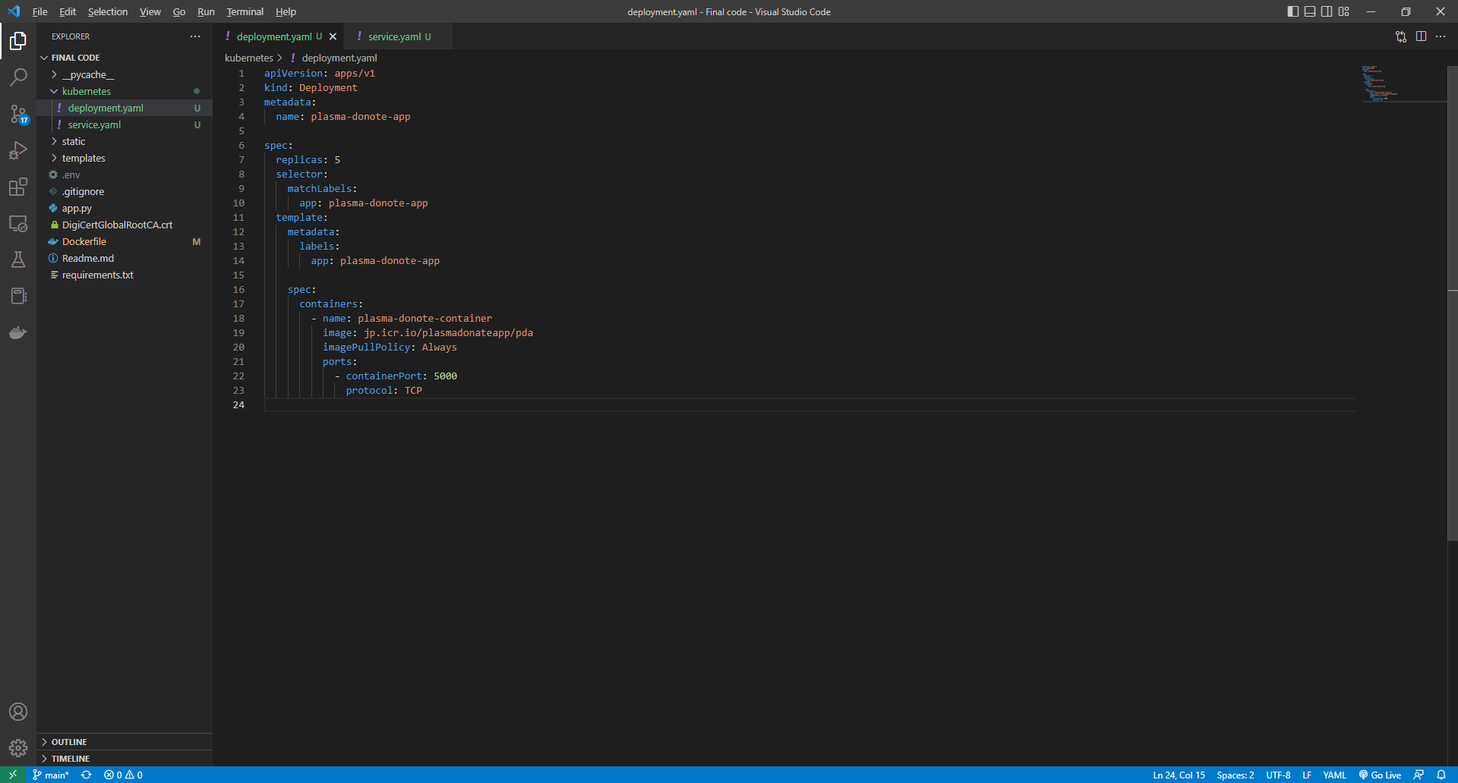

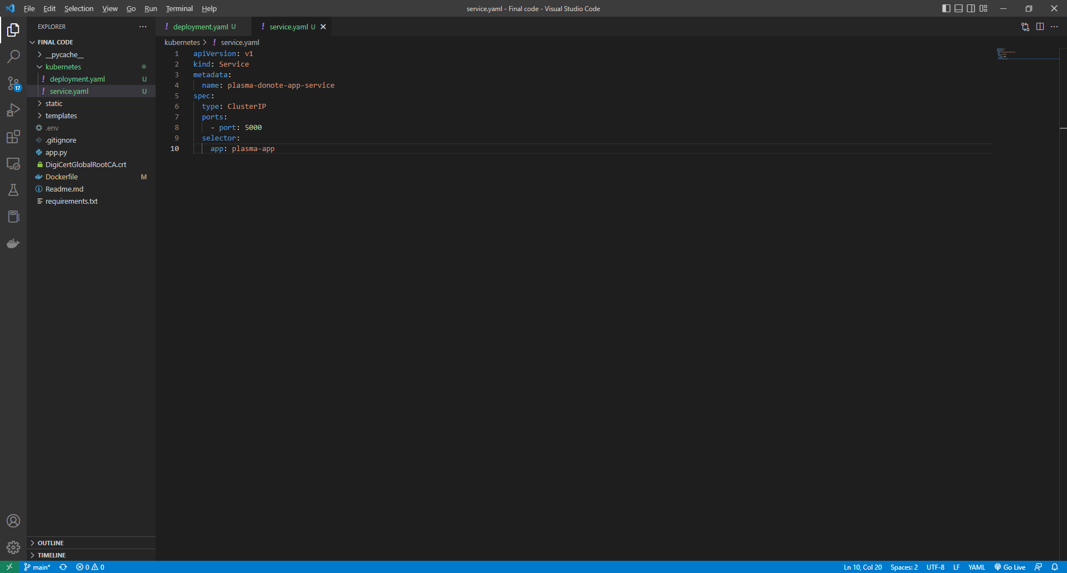

1. Deploy your application to Kubernetes

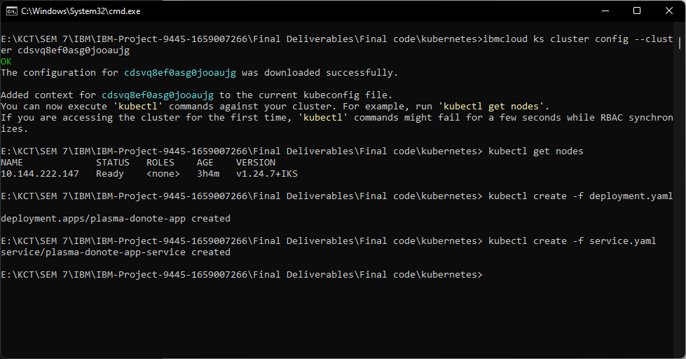

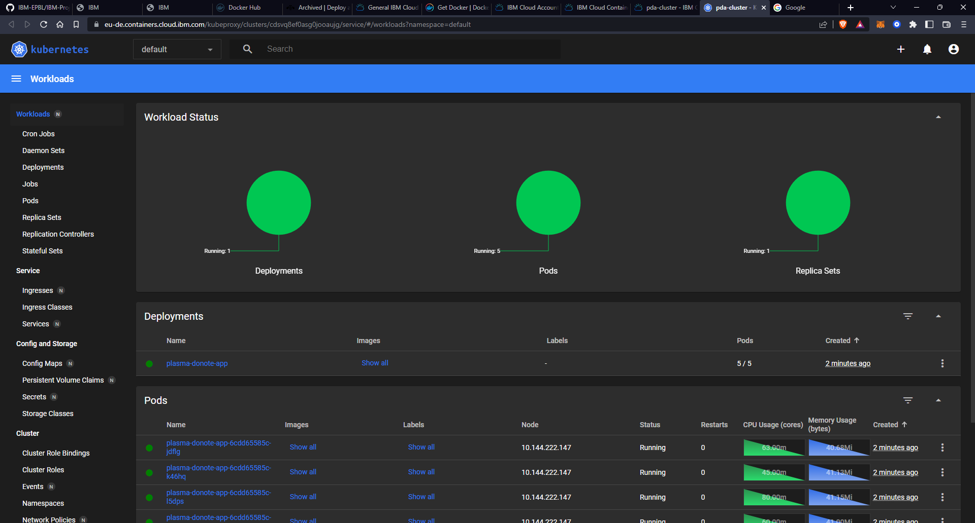

1. Go to your browser and ping the Public IP of your worker node.